District Rocky Mountain held its autumn meeting at the Miller Coors Brewery in Golden on November 2nd. This meeting was the annual joint meeting with the Wild West chapter of the ASBC. Ian Bearpark, of the Thwaites Brewery in Lancashire, England, spoke on the subject of “English Cask Beer – Brewing, Filling and Drinking.”

The meeting started off with a social hour in the bar on the 6th floor of the brewery, featuring a selection of beers from Miller Coors and A.C. Golden. There was an impressive collection of sour beers from A.C. Golden that were remarked on throughout the social hour and dinner by the crowd. Across the board, all comments were incredibly positive!

After the social hour, attendees enjoyed a delicious catered Mexican dinner graciously provided by Miller Coors. After dinner, President Gary Dick ushered the crowd into the auditorium for the educational presentation. Because time was short, there was no business meeting.

Technical Chairman Finn Knudsen of Knudsen Beverage Consulting then introduced the guest speaker, Ian Bearpark. Ian worked in Romford, Alloa and Tetley’s breweries for Carlsberg before joining Thwaites Brewery. He’s also worked with Adnams and Black Sheep on their cask beer expansions.

Ian’s talk was incredibly engaging and humorous. He started off with a short history of cask beer in England. Until the 1950’s, there were two types of English ale, mild and bitter. As beer started to be found in kegs and was now filtered and pasteurized, CAMRA (the Campaign for Real Ale) sprang up to protect the more traditional cask style of beer. Cask beer differs from keg beer in that it is unfiltered, contained finings (and thus is neither vegetarian nor allowed under the Reinheitsgebot), and often uses sugar or caramel.

Today, 6 million hectoliters of cask beer are brewed annually, which is about 8% of the total UK beer market. It is made by about 550 small local breweries and a few larger regional breweries. It varies in strength anywhere from <3% abv to >6% abv, though lighter strength is more common. Most breweries fill firkins, which hold 9 gallons. However there are a couple of breweries that still use the largest cask size, the hogshead, which holds a whopping 54 gallons.

Ian addressed the topic of what is “good” cask beer according to the standards in English pubs. It should be clear and bright, taste fresh, have natural carbonation (and not be flat), and have a healthy head. The correct serving temperature is between 10-13°C. A cask beer should be a session beer, therefore between 3-4.5% abv. Finally, it should have a nice balance between malt and hops.

Next Ian discussed how the casks are prepared and filled. They are traditionally filled under atmospheric conditions. In some places they are filled prior to the end of

fermentation so that residual sugar and yeast are available for a secondary fermentation. Otherwise they are finished in the fermenter, and sugar is added to the cask. Finings are added, usually to the cask itself though sometimes auxiliary finings are added to the racking tank. They are silica based, made from the swim bladders of sturgeons, and mixed with acid to produce collagen. Positive charges between the particles force coagulation.

One limitation that exists with casks is that while finings force the yeast to settle out and therefore produce clear beer, if the cask is agitated at all (moved to another location, for example), time is needed to resettle the yeast. Marstens Brewery has developed a new type of finings known as FastCask, which has solved this problem whereby their finings keep the yeast out of solution even if the cask is moved.

Ian also discussed the cask filling process, and showed a few slides and videos of automated and semi-automated filling lines. Many English breweries today have automated cask cleaning machines and they counter-pressure fill their casks to avoid foaming.

Last, Ian reached the topic of cask serving. He showed many pictures of beer engines for serving, and one video of the proper pour using a beer engine. Today many beer engines use cooling jackets to serve the beer at the precise temperature. They also have sparklers on the end of the gooseneck to help produce a frothy head. He completed his talk on a cheerful note, stating that more and more cask beer drinkers today are locavore, younger people, and that there is a definite ongoing market for casks because of their low carbon footprint. Ian credits CAMRA (and its members, who he described colorfully) with the survival of this brewer’s art.

As is customary, the evening concluded with a very lively raffle of prizes supplied by many of the members, including a large selection of shirts and glassware. The next meeting of District Rocky Mountain will be held in Denver on February 8th, 2012, hosted by the Sandlot Brewery.

Tamar Banner
Publicity Chair
Master Brewers Association of the Americas - District Rocky Mountain
November 23, 2011
Attached photos:

Photo 1: Grady Hull of NBB, John Legnard of Sandlot, and Jeff Cornell of AC Golden.
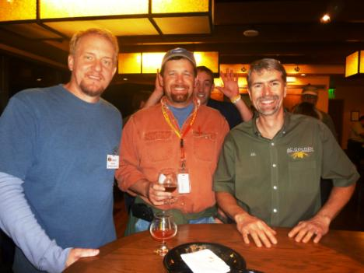

Photo 2: Chuck Campagna of Glenwood Canyon, Perry Dickerson of NBB, Matt Thrall of Avery Brewing and John Rich of NBB eating dinner.
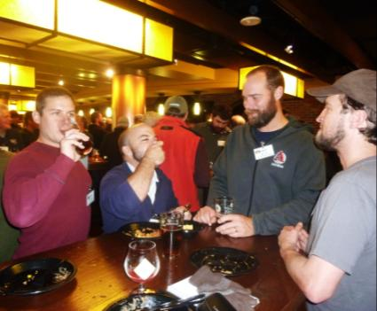

Photo 3: Ian Bearpark of Thwaites Brewery, speaking to the crowd.
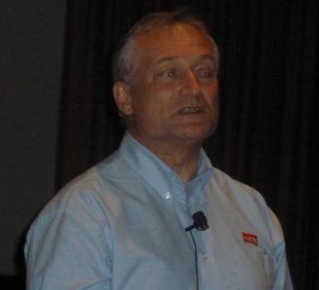

Photo 4: Tech. Chair Finn Knudsen presenting Ian Bearpark with a thank you gift for his presentation.
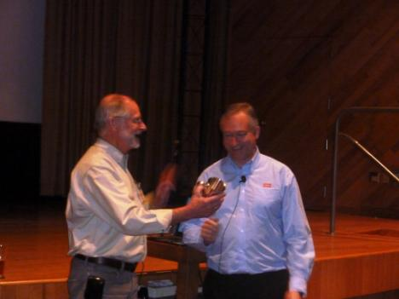

Photo 5: Mark Sample, Matt Sholbrock, and Ro Guenzel, the Left Hand brew crew.
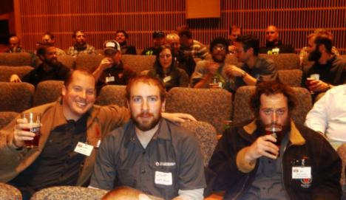

Photo 6: Kevin and Derek of Chem Station, ready for an enthralling technical presentation.
